1. Go to SE51. Check System Status.

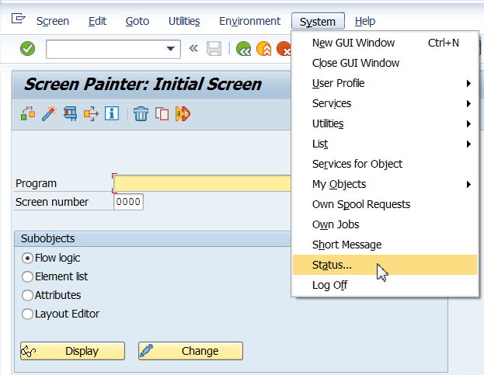

1. Double Click on program name.

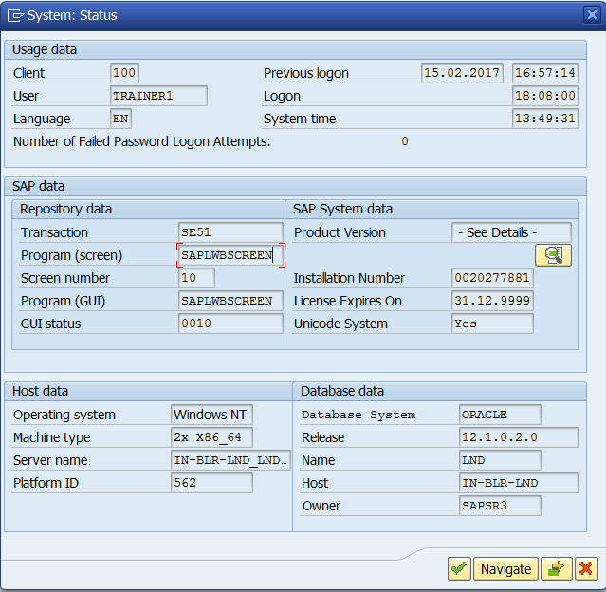

1. In SE38, Go to Attributes check the package name.

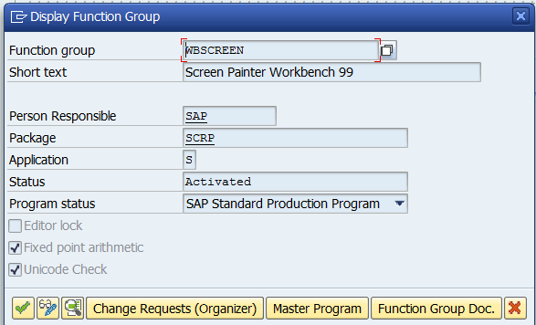

1. Go to SMOD
2. Click on Information System.

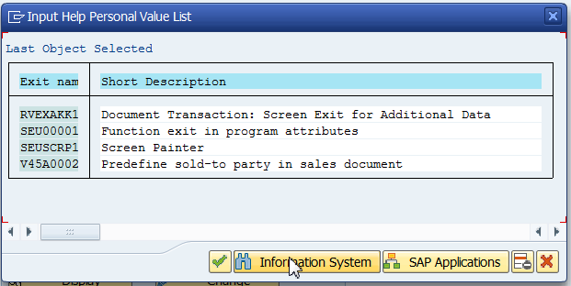

1. Enter package name and click continue.

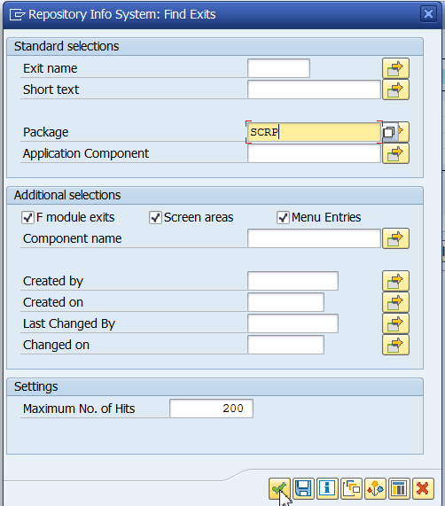

1. Observe the exit.

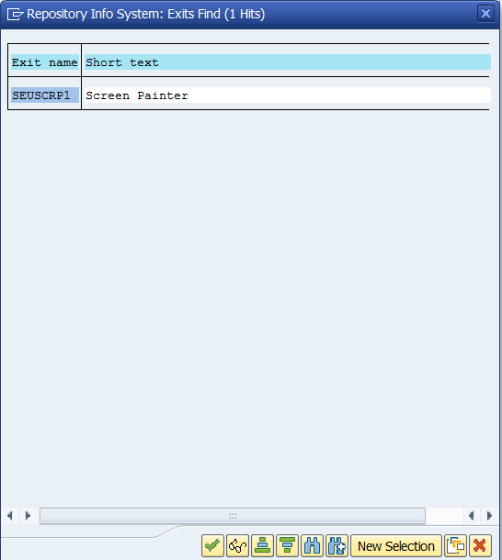

1. SEUSCRP1 is the exit we need to modify.
2. Go to CMOD

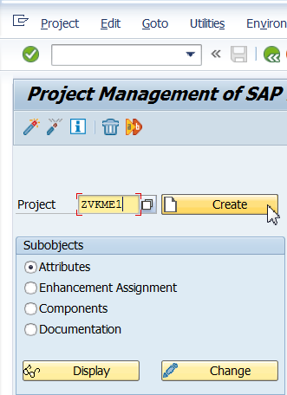

1. Click on Enhancement Assignments

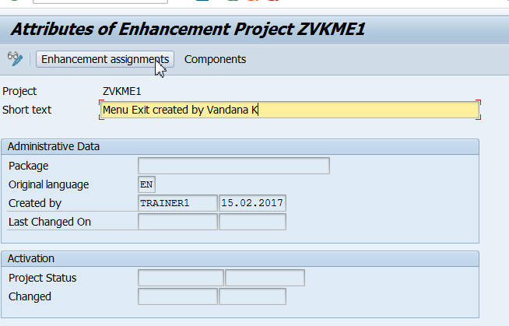

1. Save it in a package or as a local object.
2. Enter the enhancement name as shown below and press enter. The text is automatically displayed.

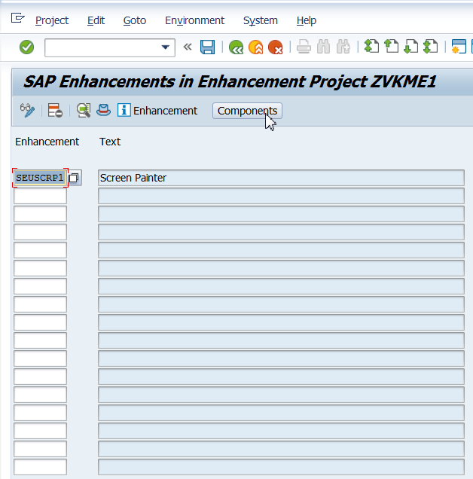

1. Double click on the selected exit.

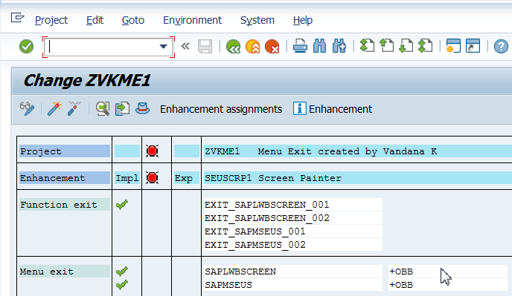

1. Enter Function Text as shown below and click on Copy.

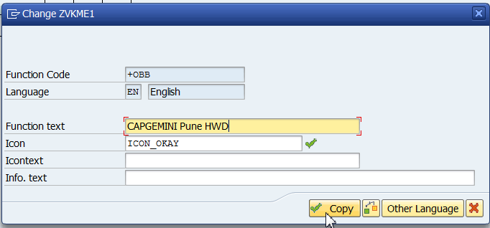

1. Activate.

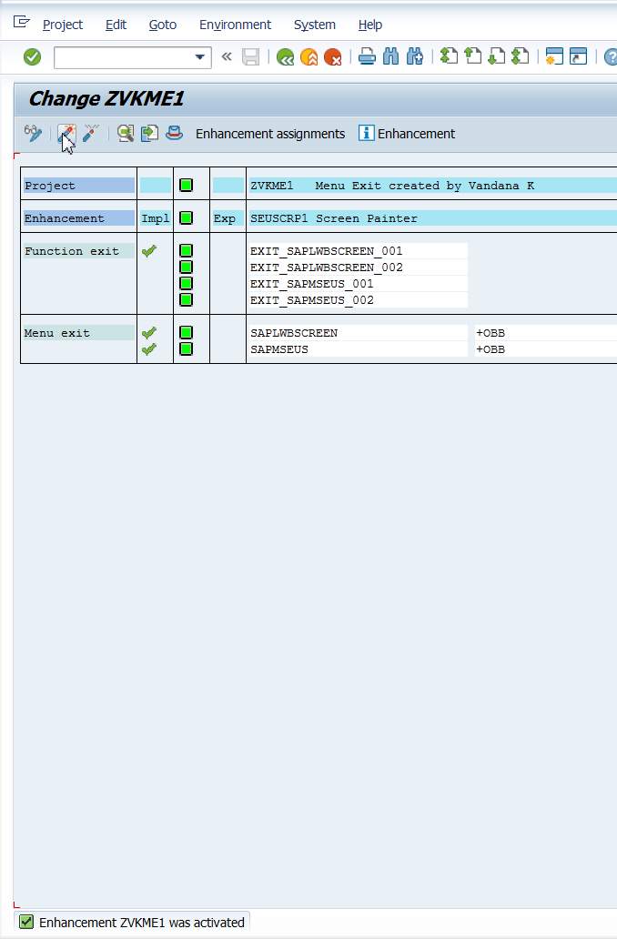

1. Go to SE51 and observe the Menu.

